Vehicle Reservation System
Use Case Document


 | Prepared By / Last Updated By | Reviewed by | Approved By
Name | Suham pandey | Gopal Upadhyay
Role | Team Member | Scrum Master
Signature | Subham Pandey | Gopal Upadhyay
Date | 25/04/19 | 25/04/19

Table of Contents
1.0 Introduction 3
1.1 Purpose & Scope of the document 3
1.2 Intended Audience 3
1.3 Use case ‘User Registration’ 3
1.3.1 Use case attributes 3
1.3.2 Use Case Model 4
1.3.3 Business Rules 4
1.3.4 UI Requirements 4
1.3.5 UI Field Validations 5
1.4 Use case ‘User Credential Authentication’ 6
1.4.1 Use case attributes 6
1.4.2 Use Case Model 7
1.4.3 Business Rules 7
1.4.4 UI Requirements 7
1.4 Use case ‘Update Vehicle Details’ 6
2.0 Database Design 8
2.1 Tables Structure 8
3.0 Change Log 10

Introduction

Purpose & Scope of the document
The purpose of this Use case document is to systematically capture requirements for the project and the system to be developed in terms of use cases. Functional use cases are captured in this document. It also serves as the input for the project scoping.

The scope of this document is limited to addressing the use cases from a user, quality, and non-functional perspective.

Intended Audience
Each member of the project team

Use case ‘User Registration’

Use case attributes
Use Case Description:

This use case deals with the capture of user details. The ‘user’ here shall be the operator of the system and will be keying in the vehicle information into the system.

Scope:

- User registration

Actors:

- User – the operator

Trigger:

Click ‘Submit’ button in the ‘User Registration’ page

Pre-Condition:

User being able to access the homepage & get redirected to the ‘User Registration’ page upon click of ‘new user’ link.

Post Condition:

User is in the enrollment page & submit details.

Flow of Events:

User at homepage → Click ‘new user’ link → User is in the enrollment page → User details are submitted and added onto the database

Primary Scenario:
A new user – is able to click ‘new’ user’ link and able to provide his details and get enrolled in the system.

Use Case Model

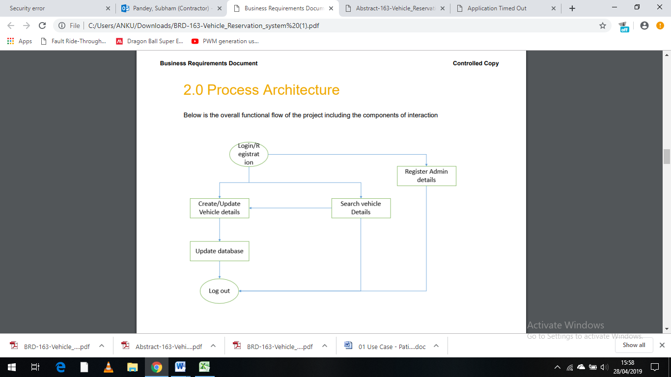

Business Rules

Business rules should be defined using the following attributes: -

- When the user clicks on the registration link, it should re-direct to registration form.
    - User needs to fill some of the basic attributes/fields as mentioned below in requirement: First Name, Last Name, Age, Gender, Employee Id, Email id, Password, Branch Id
- Clicking ‘Submit’ should validate the datatype constraints for each field
- Post-successful field level validation, save the information in the database
- Upon saving the information in the database, display the message ‘New User registered successfully’.

UI Requirements
.
User Homepage
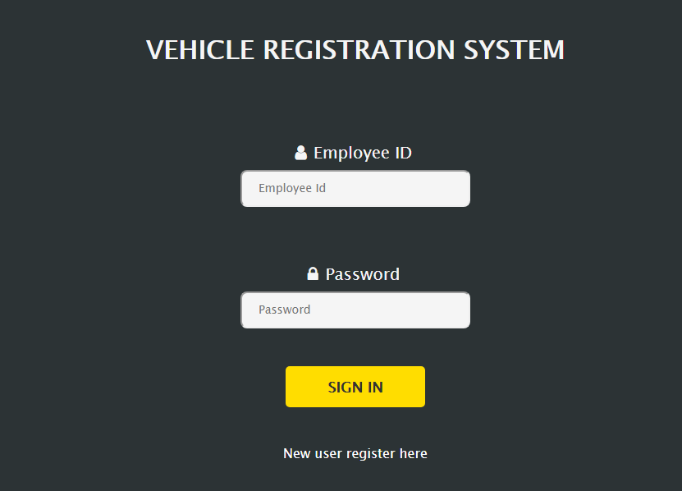

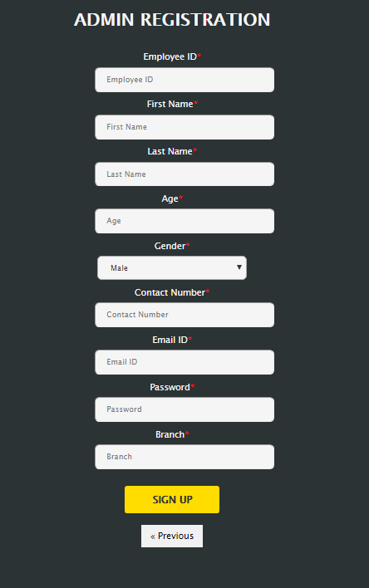
User Registration

UI Field Validations
Please refer to the below requirements for field level validations:

- All fields are mandatory.
- User Id and Password should be less than 15 chars and minimum of 5 chars, no space & can contain atleast one Uppercase,Lower Case and Digit.
- First Name and Last Name must have atleast one uppercase and one lower case.
- The Email ID format must be checked. (For ex. test@testmail.com.)
- Phone Number must be of 10 digits’ length

Use case ‘User Credential Authentication’

Use case attributes
Use Case Description:

This use case deals with the authentication of the user credentials. The ‘user’ here shall be the operator of the system and will be keying in the vehicle information into the system.

Scope:

- User credentials authentication

Actors:

User – the operator

Trigger:

Click ‘Login’ link, after keying in ‘UserID’ & ‘Password’ field.

Pre-Condition:

User being able to access the homepage

Post Condition:

User is in the Vehicle reservation homepage

Flow of Events:

User at homepage → Key in ‘UserID’ & ‘Password’ field → User credentials are validated → Vehicle reservation homepage is displayed

Primary Scenario:
A registered user – is able click ‘Login’ link, after keying in ‘UserID’ & ‘Password’ field and get his credentials authenticated with the existing database entry.

Alternative Scenario:
A registered user – is able click ‘Login’ link, after keying in ‘UserID’ & ‘Password’ field and unable to get his credentials authenticated. The user is presented with relevant error messages:

- Invalid User ID – ‘Invalid User Credentials’
- Incorrect Password – ‘Invalid User Credentials.’

Use Case Model
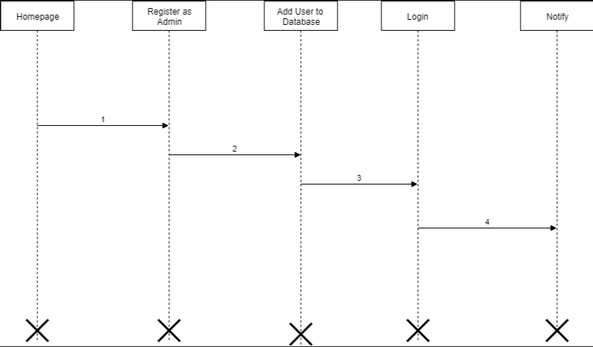

Business Rules

Business rules should be defined using the following attributes:-

- A registered user – is able click ‘Login’ link, after keying in ‘UserID’ & ‘Password’ field and get his credentials authenticated with the existing database entry.

UI Requirements
Here is a prototype on how the patient registration should look like.

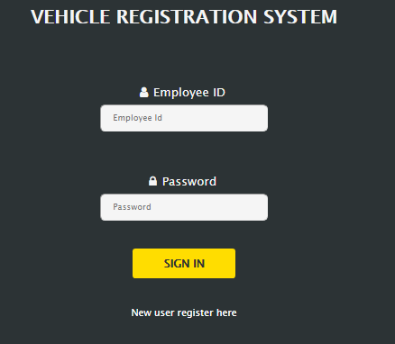

Use case ‘Update Vehicle Details’

Use case attributes
Use Case Description:

This use case deals with the capture of vehicle details. The ‘user’ here shall be the operator of the system and will be keying in the vehicle information into the system.
.
Scope:

- Create new vehicle
- Update vehicle deails

Actors:

- User – the admin

Trigger:

Click ‘Submit’ button in the ‘Vehicle Registration’ page

Pre-Condition:

User being able to access the homepage & getting the access to click ‘Create new Vehicle’ and ‘update vehicle details’ page

Post Condition:

User is in the vehicle details page & submit details.

Flow of Events:

User at homepage → Click ‘create new vehicle’ link → User is in the vehicle details page → vehicle details are submitted and added onto the database

User at homepage → Click ‘update vehicle’ link → User is in the vehicle details page → vehicle details are submitted and added onto the database

Primary Scenario:
For a new vehicle –admin is able to click ‘create new vehicle’ link and able to provide his details and get enrolled in the system.

Use Case Model
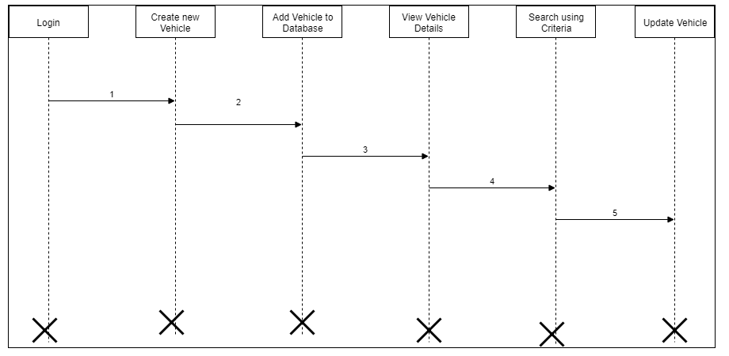

Business Rules

Business rules should be defined using the following attributes:-

    - Update Details page should display all the fields- Vehicle No, vehicle type, Branch, insurance type, insurance expiry date, last Serviced Date, Service due date.
    - The above-mentioned fields should have the previous updated data of the respective vehicles, which could be directly edited by the admin.
    - Clicking Submit Button without providing any of the mentioned field must display an error.
    - On successful validation, the information must be saved in the vehicle details database.

UI Requirements
Here is a prototype on how the patient registration should look like.

Vehicle Registration Homepage

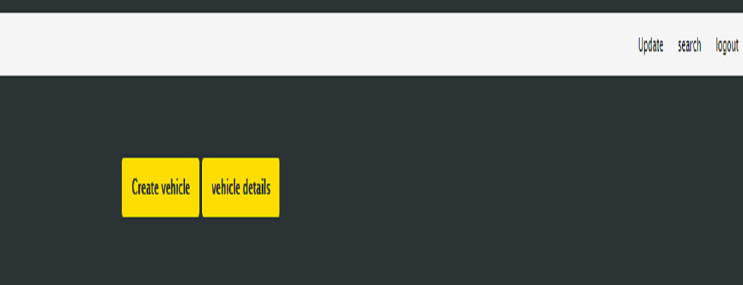

Create new Vehicle
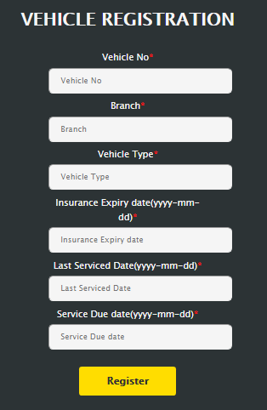

Update Existing Vehicle
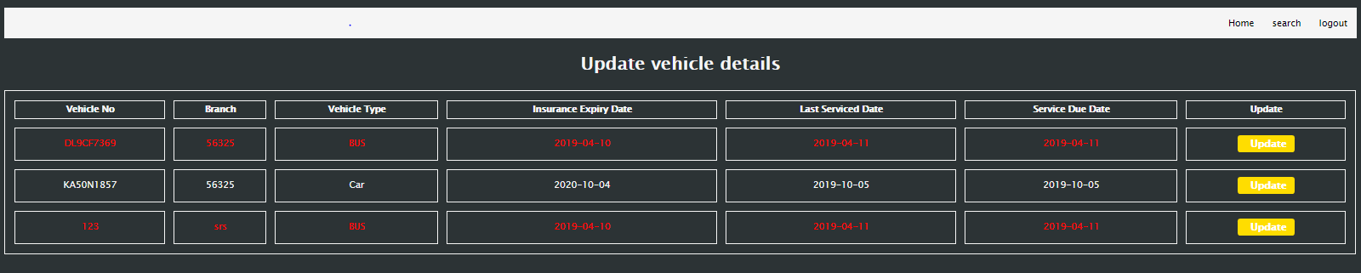

View Vehicle Details
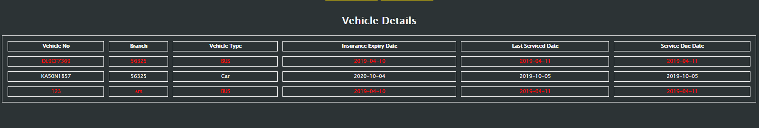

Use case ‘Search Vehicle details’

Use case attributes

Use Case Description:

This use case deals with the searching of existing vehicle details in the database by the admin .The admin here can fetch for any vehicle details depending on some mentioned criteria.
Scope:
Search Vehicle Details page should display all the fields which can be selected by the admin:
- Branch
- Vehicle type
- Insurance expiry month
      - service due month
Actors:

- User – the admin

Trigger:

Click ‘Search’ button in the ‘Vehicle Registration’ homepage

Pre-Condition:

User being able to access the homepage & getting the access to click ‘Search Vehicle’ button

Post Condition:

User is in the vehicle details page with details of vehicle in a tabular structure.

Flow of Events:

User at homepage → Click ‘search vehicle’ link →Select the criteria for searching → User is in the display vehicle details page

Primary Scenario:
For searching vehicle –admin is able to click ‘search vehicle’ link and able to provide his details and get enrolled in the system.

Business Rules

Business rules should be defined using the following attributes:-
- Either of the mentioned criteria’s must be selected by the admin.
- Admin on selecting the search criteria and clicking search, vehicle details- Branch, vehicle type, vehicle number, insurance expiry date, service due date should be listed from the database in a tabular form.
- While viewing the vehicle details, If Expiry of Insurance or Service due falls in next 15 days then the data should be highlighted in red, from the Vehicle details listed.

UI Requirements

Here is a prototype on how the Search Vehicle details should look
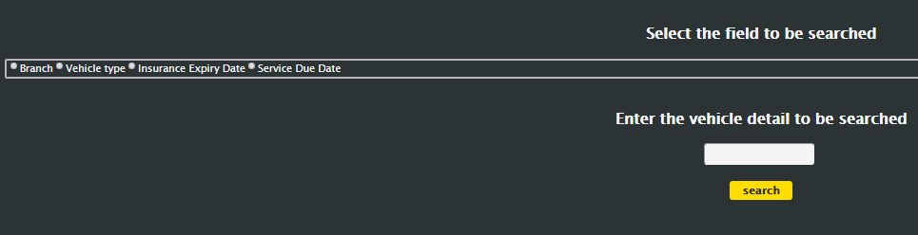

Use case ‘Notify Admin’

Use case attributes

Use Case Description:

This use case deals with notifying the admin. The admin here is sent an email notification when expiry of Insurance is in next 15 days or Service due in next 15 months
Scope:
Notifying admin

Actors:

- User – the admin

Pre-Condition:

Expiry of Insurance is in next 15 days or Service due in next 15 months

Post Condition:

Admin should receive an email notification regarding the vehicle expiry of insurance .

Primary Scenario:
For searching vehicle –admin is able to click ‘search vehicle’ link and able to provide his details and get enrolled in the system.

Business Rules

Business rules should be defined using the following attributes:-
- Batch job should be run fortnightly to trigger Email notification to admin to notify – Expiry of Insurance in next 15 days or Service due in next 15 months

Database Design

Tables Structure
User Registration:
 | Column Name |  |  |  | Data Type |  |  |  | Length |  | Nulls
 | Employee Id |  |  |  | nvarchar |  |  |  | 6 |  | N
 | First Name |  |  |  | nvarchar |  |  |  | 15 |  | N
 | Last Name |  |  |  | varchar |  |  |  | 50 |  | N
 | Age |  |  |  | varchar |  |  |  | 50 |  | N
 | Gender |  |  |  | int |  |  |  | 2 |  | N
 | Contact Number |  |  |  | varchar |  |  |  | 10 |  | N
 | Email |  |  |  | long |  |  |  | 10 |  | N
 | Password |  |  |  | nvarchar |  |  |  | 15 |  | N
 | Branch |  |  |  | varchar |  |  |  | 15 |  | N

User login:

Column Name | Data Type | Length | Nulls
Employee Id | nvarchar | 15 | N
Password | nvarchar | 15 | N

Vehicle Registration:

Column Name | Data Type | Length | Nulls
Vehicle No | nvarchar | 10 | N
Branch | nvarchar | 5 | N
Vehicle type | varchar | 15 | N
Insurance Expiry date | varchar | 10 | N
Last Serviced Date | varchar | 10 | N
Service Due date | varchar | 10 | N

Change Log
Version Number | Changes Made
V1.0 | Initial baseline created on <dd-Mon-yy> by <Name of Author>
V1.1 | <Please refer the configuration control tool / change item status form if the details of changes are maintained separately. If not, the template given below needs to be followed>
V1.1 | Section No. | Changed By | Effective Date | Changes Effected

